Guild Battle Power Analyzer
Start at the home page.
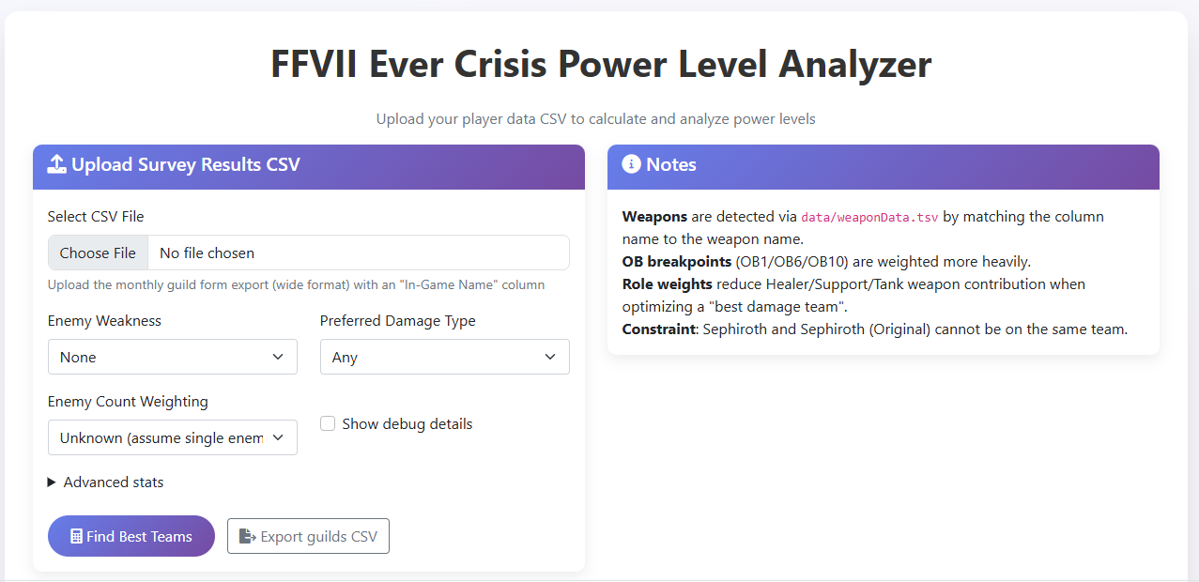
Here you have the option to upload the CSV file from the Google survey result. You can select the weakness element, the magical/physical damage type and if there is a single enemy or multiple. This is enough to go on and we will attempt to determine team synergy based on that information. If you selected magical fire, the synergy will look for the most powerful magical fire weapon including additional abilities such as mdef down and fire damage up. This can make mistakes as it is hard for synergy detection to know how certain abilities will be used. For example, in Guild Battle 20 for magic fire, the synergy detection would weight Rose Musket over Shinra Ceremonial Rifle because Rose Musket is magical and Shinra Ceremonial Rifle is physical, despite the rifle having more usefulness since Lucia is not a DPS character. Adjustments have been made to treat the roles differently, but is still can make mistakes, and we will have to continually make different tweaks as we go.

Under advanced stats you have the option of adding additional weapon to weapon abilities.
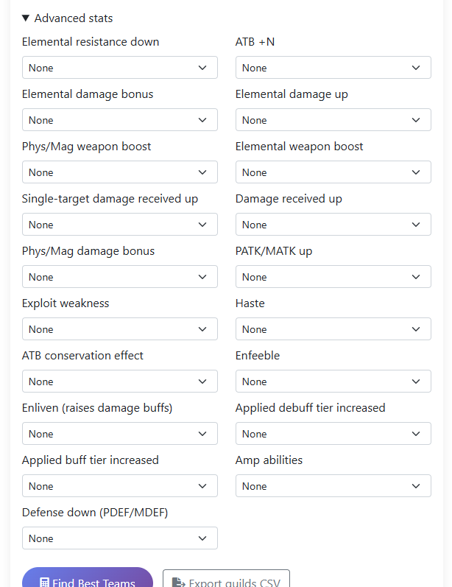
If we feel the output is not what we’d expect, we can easily just add weight to a certain ability to help it score better. If a Guild Battle requires a certain ability to be effective, such as PDEF down, we can adjust for that without code changes.

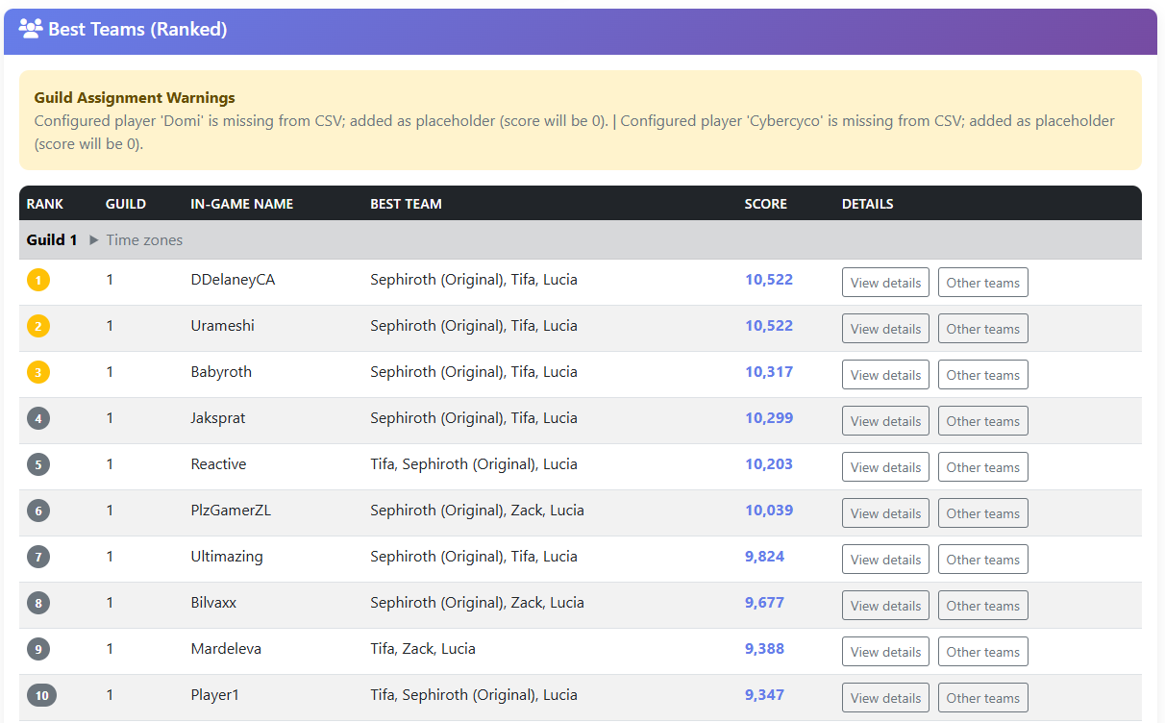
Once you click find Best Teams, it will sort all the survey results into groups of 30 for Guilds. Certain members are locked into their guilds because of their leadership responsibilities. The app will attempt to determine the best team based on the data supplied by the survey results. Since we do not have a players ENTIRE inventory of weapons, we are limited to the details we asked in the survey. So if a Guild Battle throws a curve ball at us such as adding a new weapon the day of, or requiring a weapon we did not ask about, it could scew the results. However, this should still give us a fair example of player power level on average.

Viewing the player details provide ALL of the scoring details for that player’s team.
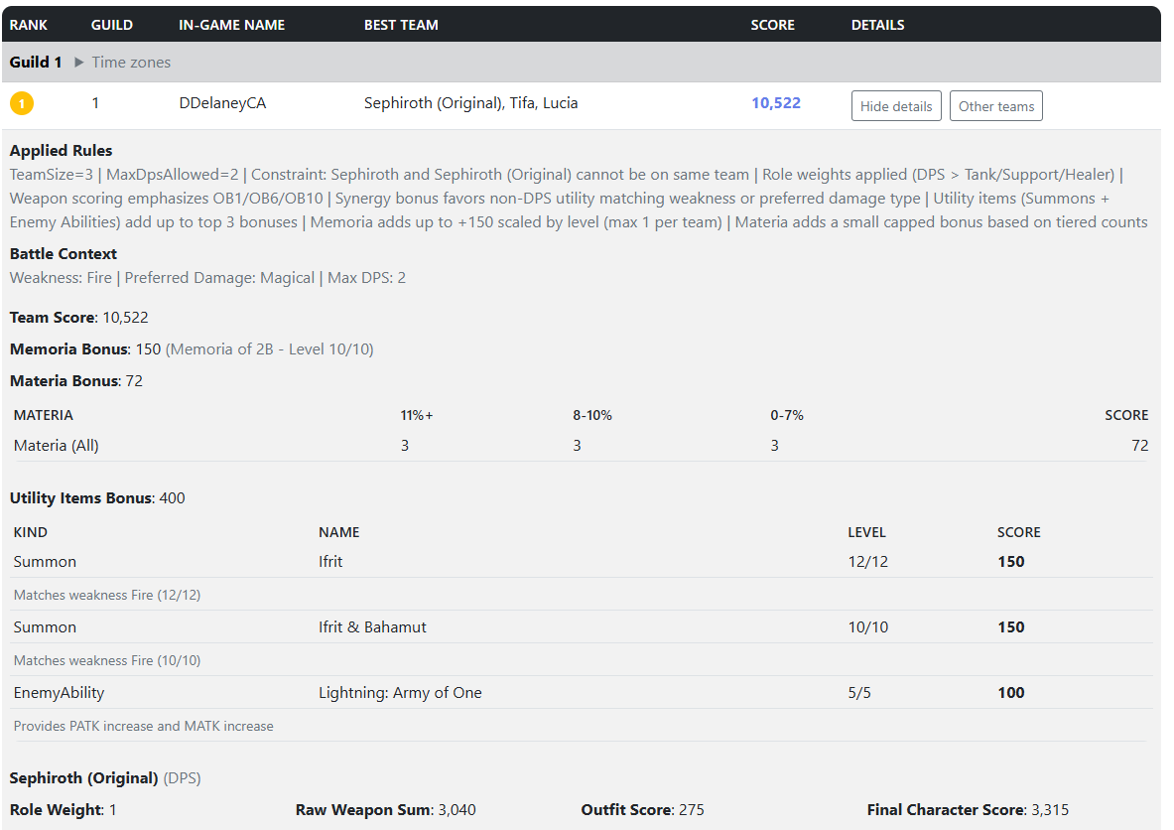
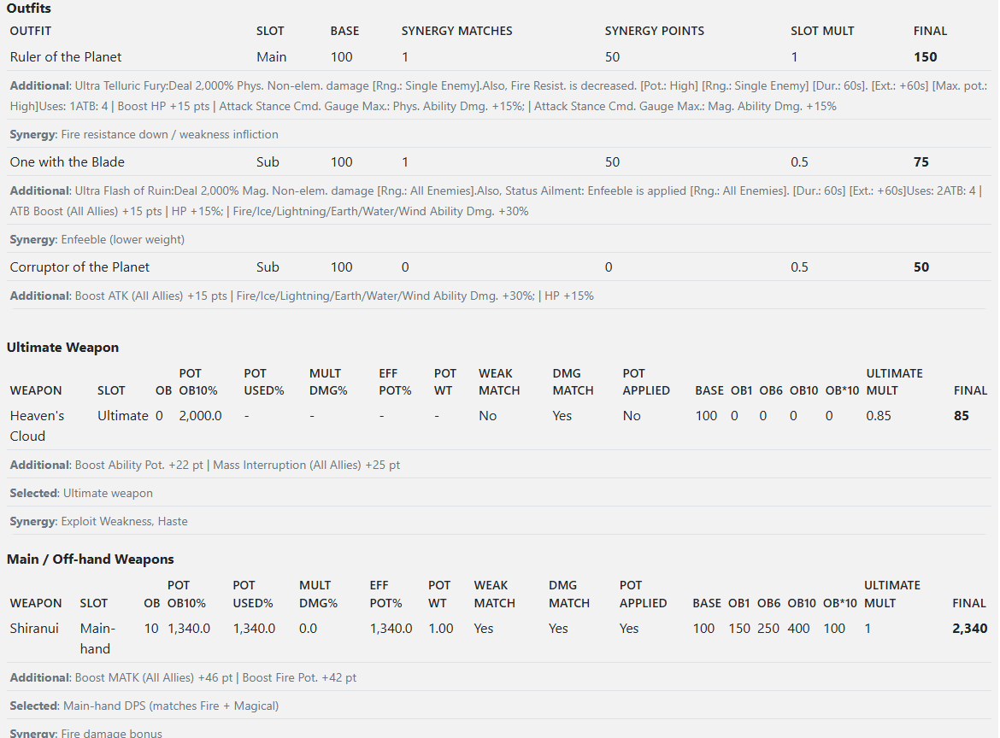
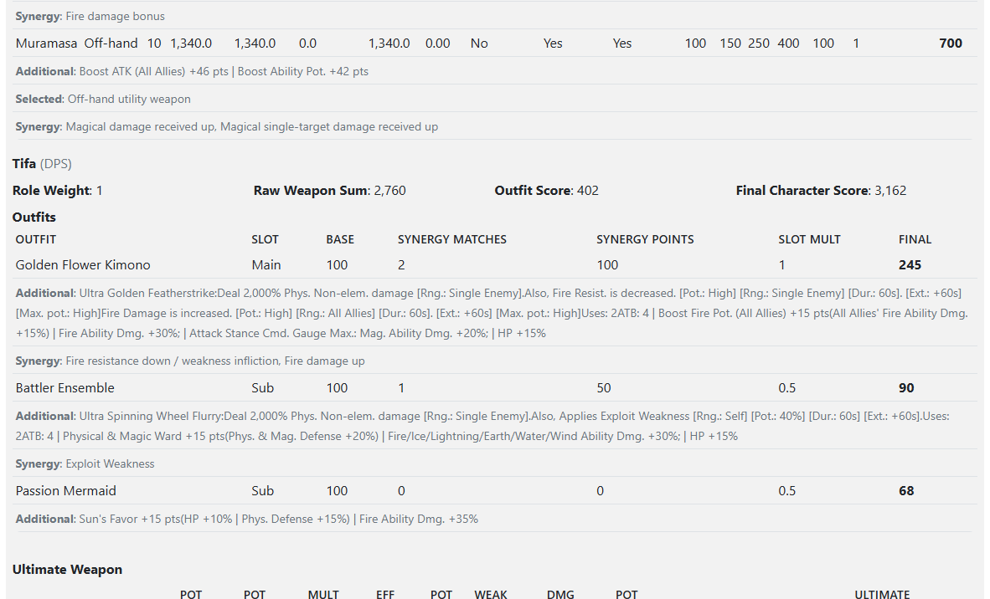

This is where we can verify how the synergy detection is working. We can examine the choices it made to determine is adjustments to the logic need to be made. Unfortunately those adjustments need to be made in code, so can be slower to implement. But clicking the Other Teams button, you can see the power levels for other team combinations it found still based on the survey results.
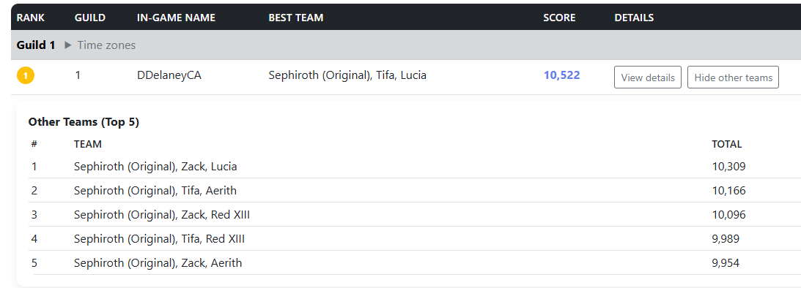

There is also a data diagnostics page. This page can tell you if there is any missing data. This includes data in the weapon database CypherSignal maintains, the additional data files use to supplement that information with R Abilities, or any combination of the above.
